Report

Date | 22 DEC 2025
Team ID | PNT2022TMIDxxxxxx
Project Name | Global Energy Trends: A Comprehensive Analysis of Key Regions and Generation Modes using Power BI
Maximum Marks | 5 Marks

Dashboard Report:
This dashboard provides a consolidated view of global energy consumption trends with a strong emphasis on regional performance, renewable vs non-renewable energy sources, and long-term growth patterns. The design enables users to quickly understand energy dominance by region, identify leading countries, and analyze the evolution of renewable energy sources over time.
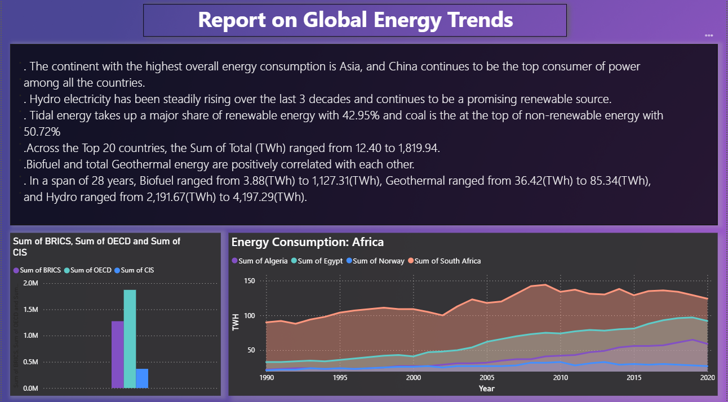
Dashboard Overview and Explanation:
1. Report Narrative Section (Top Panel)
The report narrative summarizes the most important insights derived from the data:
- Asia emerges as the continent with the highest overall energy consumption, indicating rapid industrialization and population-driven demand.
- China stands out as the top energy-consuming country, reflecting its economic scale and manufacturing dominance.
- Hydroelectric power shows a consistent upward trend over the last three decades, confirming its role as a stable and mature renewable energy source.
- Tidal energy contributes the largest share of renewable energy (42.95%), while coal dominates non-renewable energy consumption with 50.72%, highlighting continued fossil fuel dependence.
- Among the top 20 countries, total energy consumption varies significantly, ranging from 12.40 TWh to 1,819.94 TWh, indicating unequal global energy distribution.
- A positive correlation between biofuel and geothermal energy suggests parallel growth in alternative renewable technologies.
- Over a 28-year period, hydro energy shows the highest absolute growth, reinforcing its importance in global renewable generation.
Business Value:
This narrative allows decision-makers to grasp key insights without interacting with individual visuals.
2. Economic Group Comparison (BRICS, OECD, CIS)
Visualization: Clustered Column Chart
Metric: Sum of Total Energy Consumption (TWh)
- OECD countries show the highest total energy consumption, reflecting advanced industrial economies.
- BRICS nations follow closely, indicating rapid growth and increasing energy demand.
- CIS countries contribute comparatively less, suggesting moderate consumption levels.
Insight:
Economic classification plays a major role in energy demand and infrastructure development.
3. Energy Consumption in Africa (Trend Analysis)
Visualization: Line Chart
Countries Displayed: Algeria, Egypt, Norway, South Africa
Metric: Energy Consumption (TWh) by Year
- South Africa leads African energy consumption due to industrial and mining activities.
- Egypt and Algeria show steady growth, reflecting expanding population and infrastructure.
- Norway, despite being included for comparison, maintains lower but stable consumption due to efficient energy usage and renewable adoption.
Insight:
Africa shows gradual growth but remains underrepresented in global energy consumption, highlighting development opportunities.
Key Observations (Overall Dashboard)
- Global energy consumption is unevenly distributed across continents and countries.
- Renewable energy adoption is increasing, but non-renewable sources still dominate.
- Hydro energy remains the most reliable renewable source, while emerging renewables show gradual adoption.
- Economic and regional factors strongly influence energy consumption patterns.

